**Online Book Store User Guide**

**WebSite URL :** [**http://springbootonlinebookstore-env.eba-hzipvppe.us-east-1.elasticbeanstalk.com**](http://springbootonlinebookstore-env.eba-hzipvppe.us-east-1.elasticbeanstalk.com)

**Functionality:**

**User :**

* User can view all the books, Search for the books.
* Filter the books by category, price, title, name, author etc.
* Change password and forgot password functionality.
* Update the user profile.
* Update the user delivery address
* Add item to the cart.
* User can do the payment using cards, upi, Internet Banking etc.
* User can view the updates on the order.

**Admin :**

* Add Book to the database.
* Manage the order ,Update the order status and give the delivery update of the book.
* View All Books.

**Admin Credentials :**

**Username** : [admin@gmail.com](mailto:admin@gmail.com)

**Password** : admin

**Testing Payment Details :**

Select Card inside the Razorpay payment

**Payment id** : 4111 1111 1111

**Expiry** : any future month and year ( ex : 11/32)

Account holder name : Any Name (ex : ABC)

**Cvv** : any three digit number (ex : 123)

This is the Home Page of the Online Book Store Website

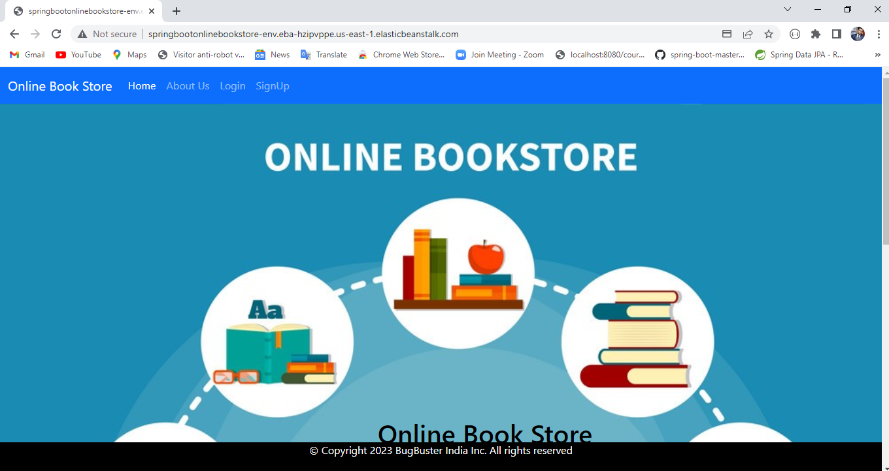

About us Page

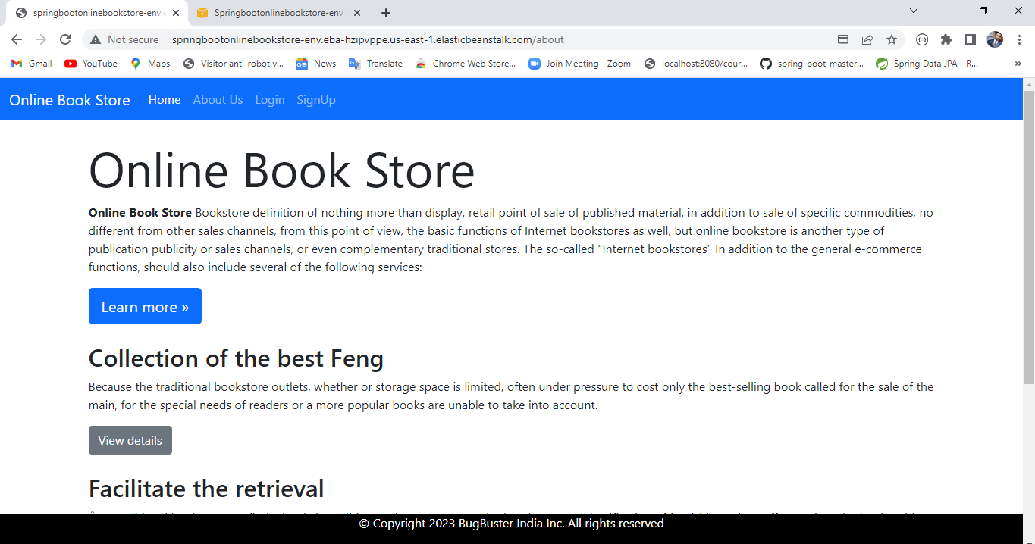

Creating an account using sing up form. The user entered password will be encrypted using the BCryptPasswordEncoder.

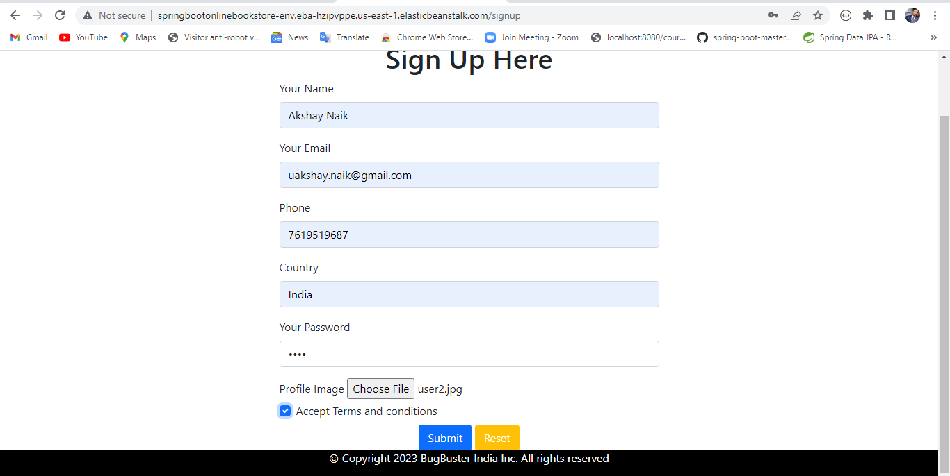

Login to the Website using the credentials.

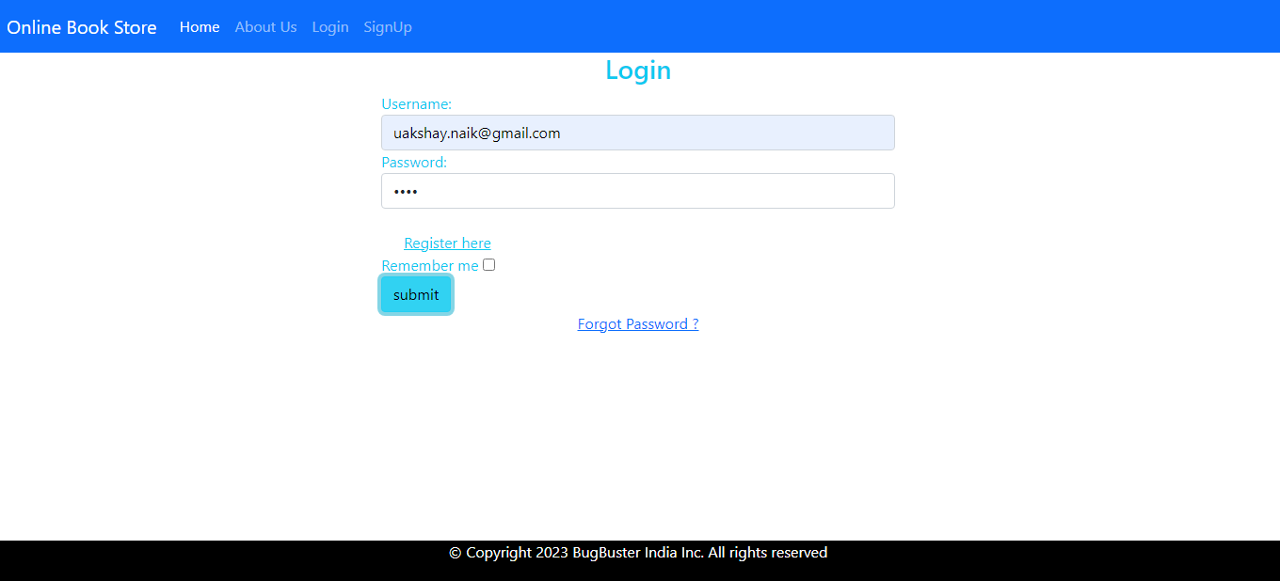

After the successful login of the normal user the webpage will be redirected to the user’s page. In the views books I have added the search , filter on books feature in ascending or descending order etc.

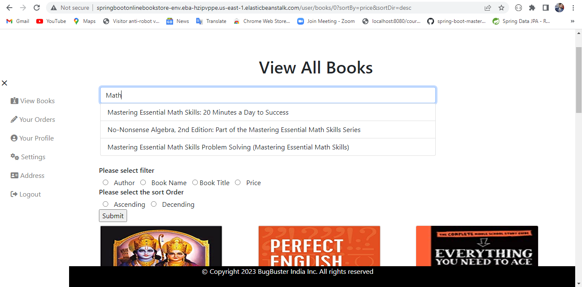

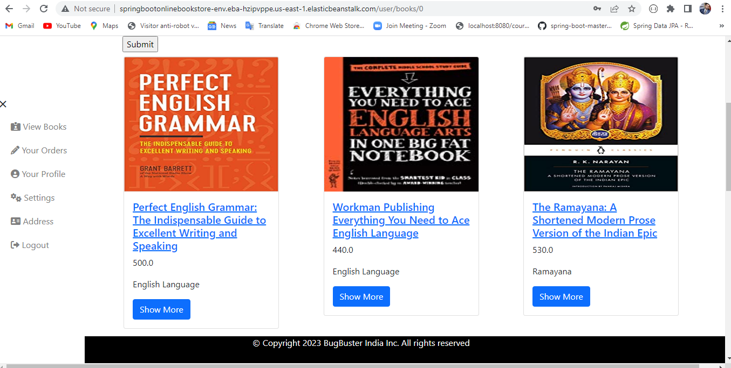

Added pagination

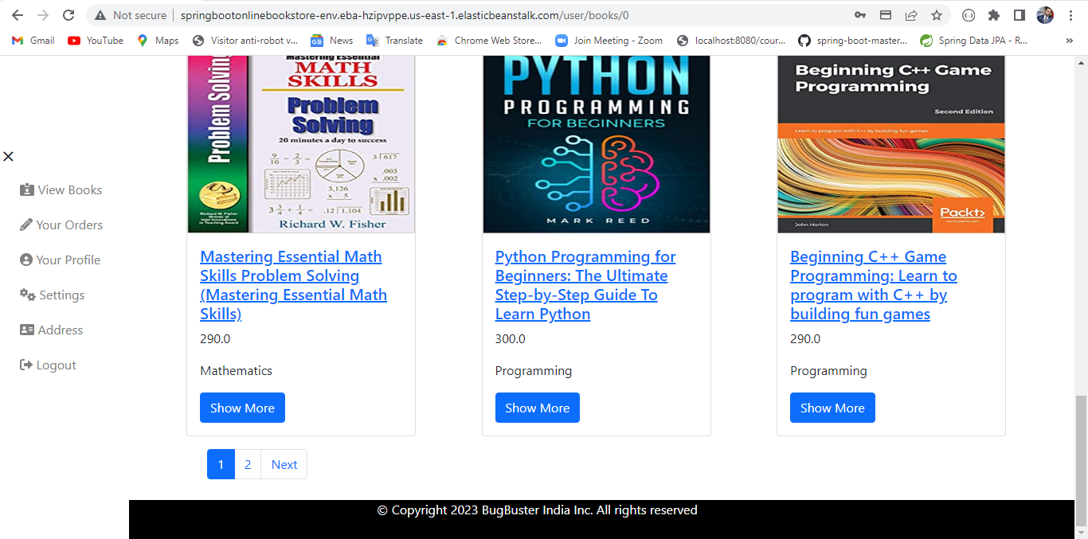

When the user clicks on the showmore of any book , it will go to the details page of particular book. Which includes add to cart button and details about the book.

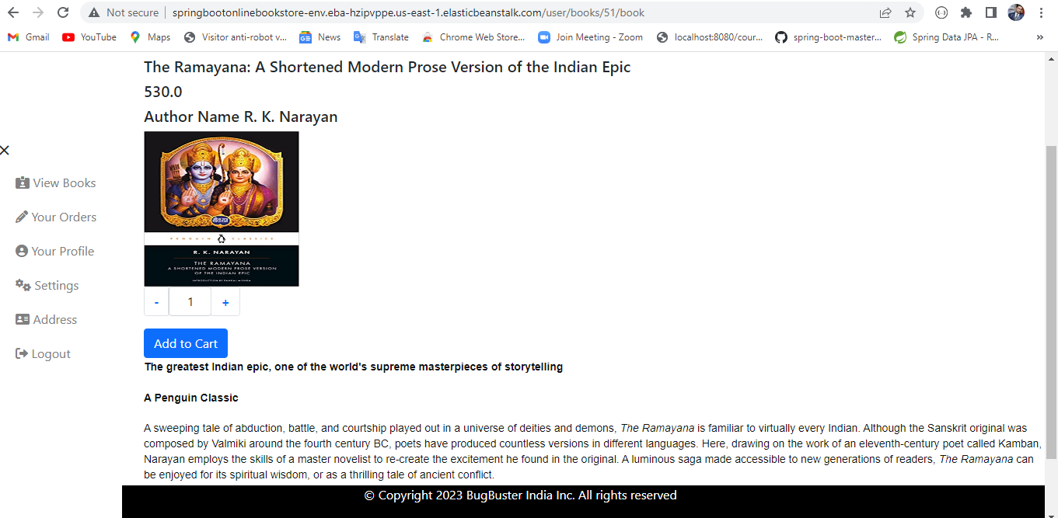

When the user clicks on the add to cart button the alert will come with the message saying that book has been added to the cart.

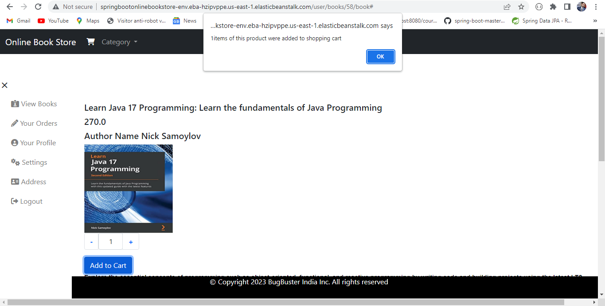

This is the cart page if the user not yet added the delivery address it will show Add address button.

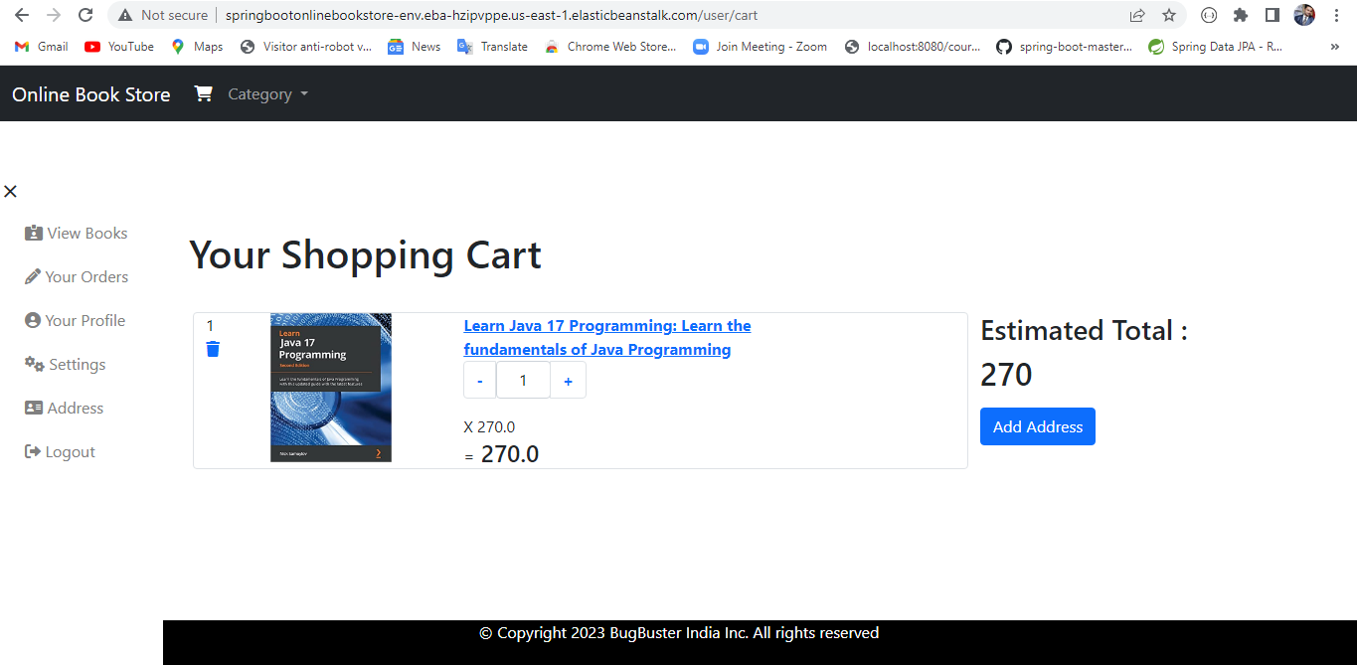

Address fill form

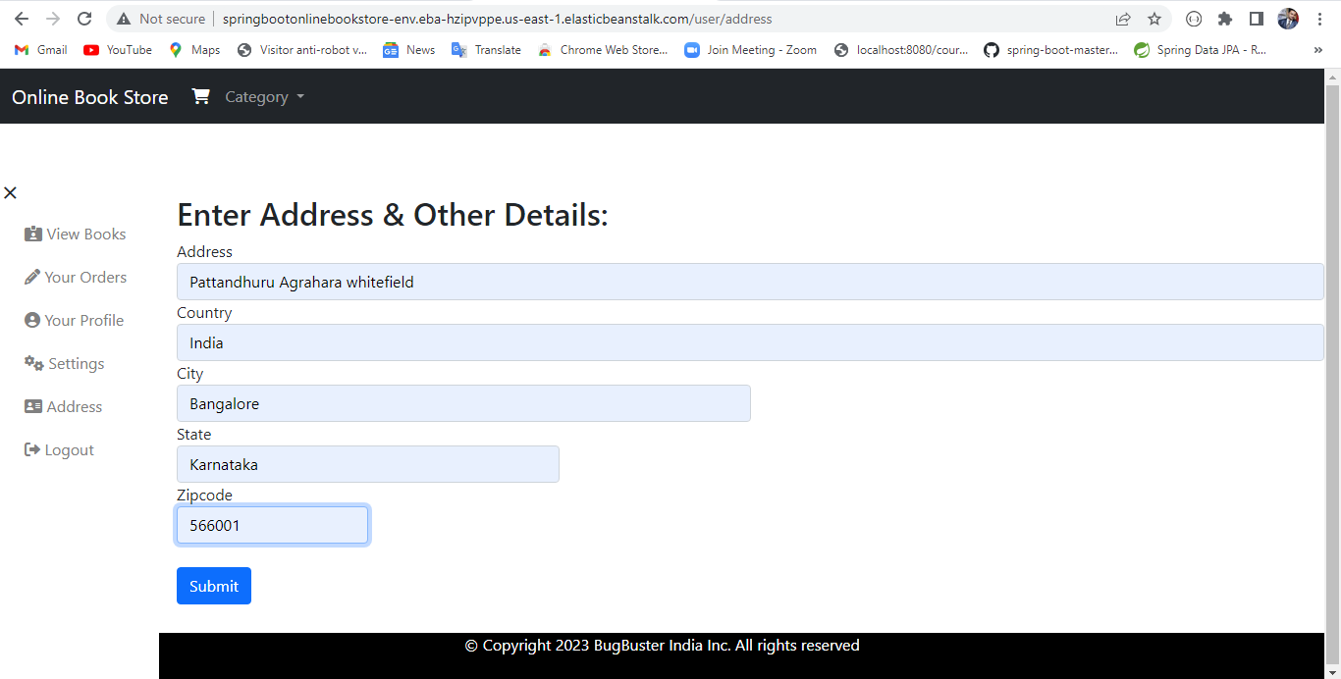

After adding the address cart page will show the checkout button

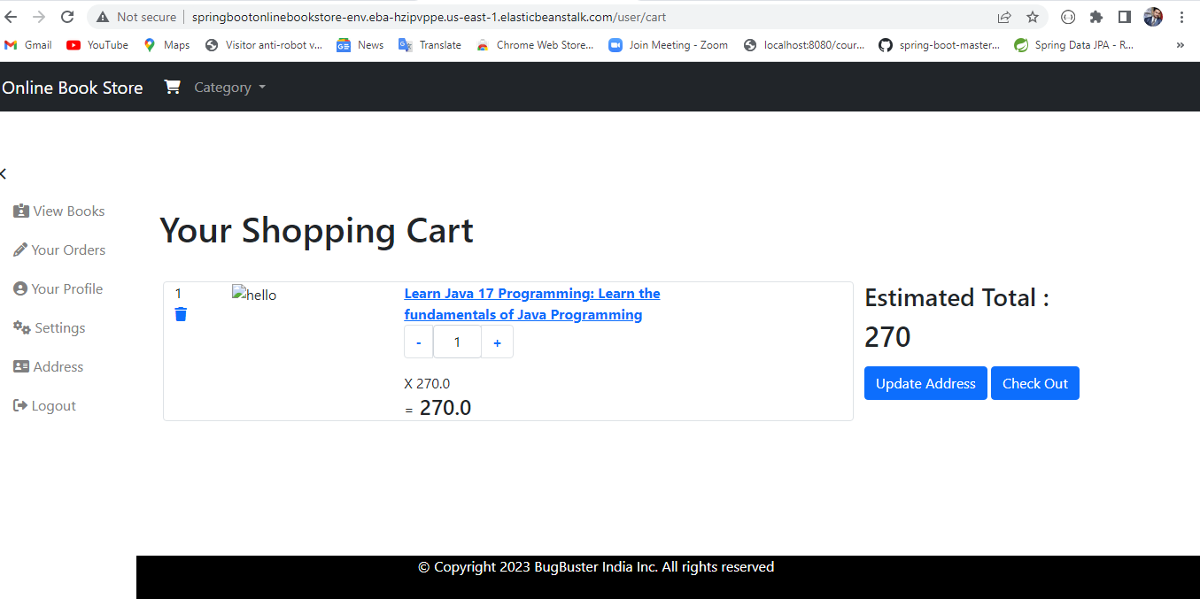

When the user clicks on the checkout button it will be redirected to the razorpay payment page. Here I am using the testing mode of the Razorpay. In Razorpay we are suppose to fill the valid phone number and email.

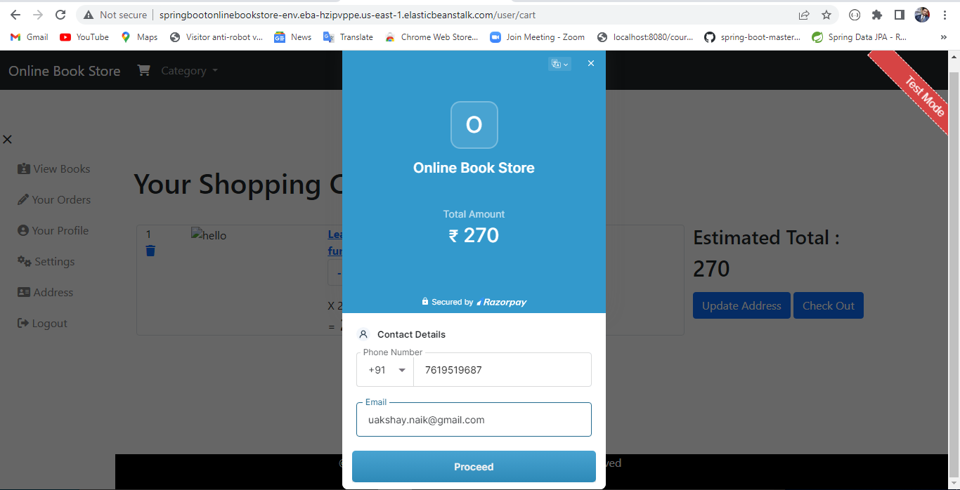

After that we need to select the any option among the available options like cards ,upi ,internet banking etc. Here I have selected the card option and filled the required credentials.

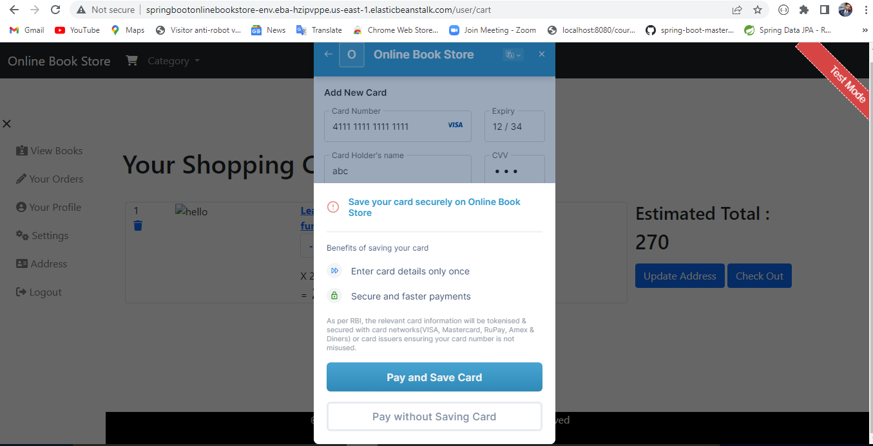

If the order is successful then the order successful sweet alert will display.

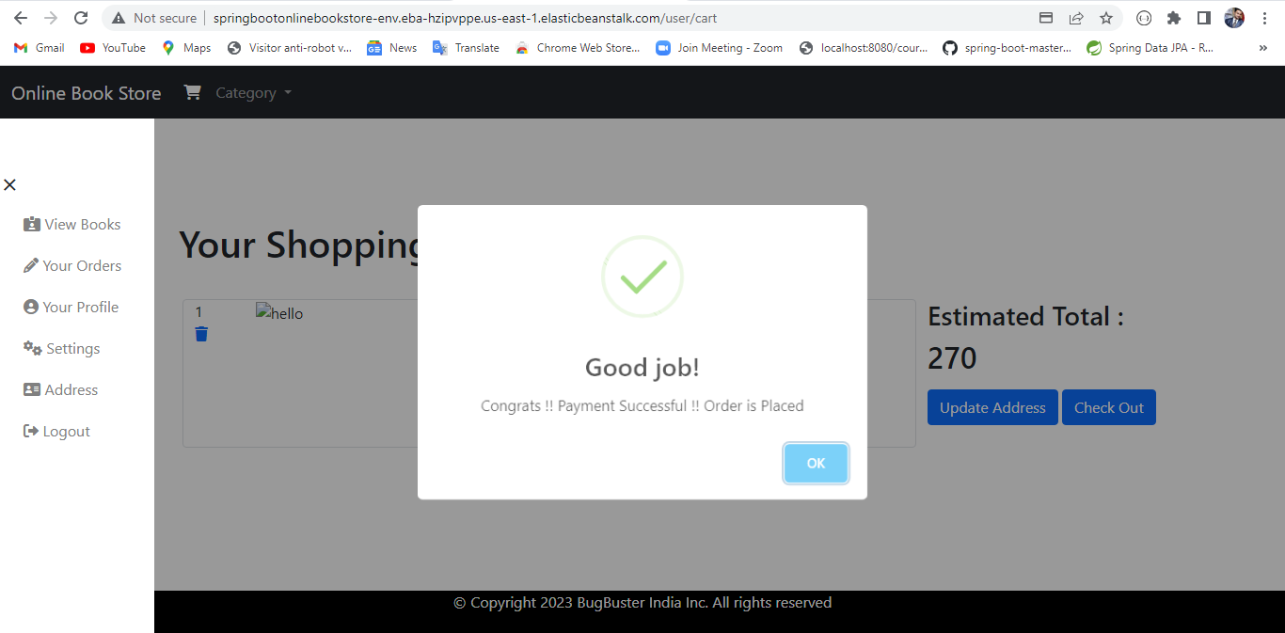

Once the order is successful the cart item will become empty.

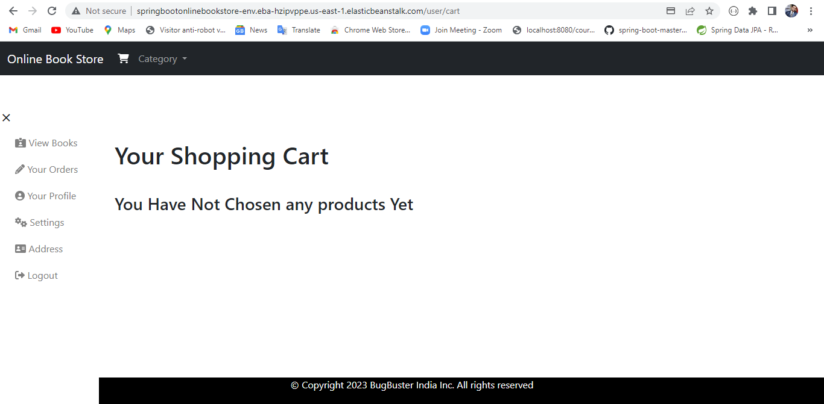

The user can see their order by clicking on the Your Orders link.

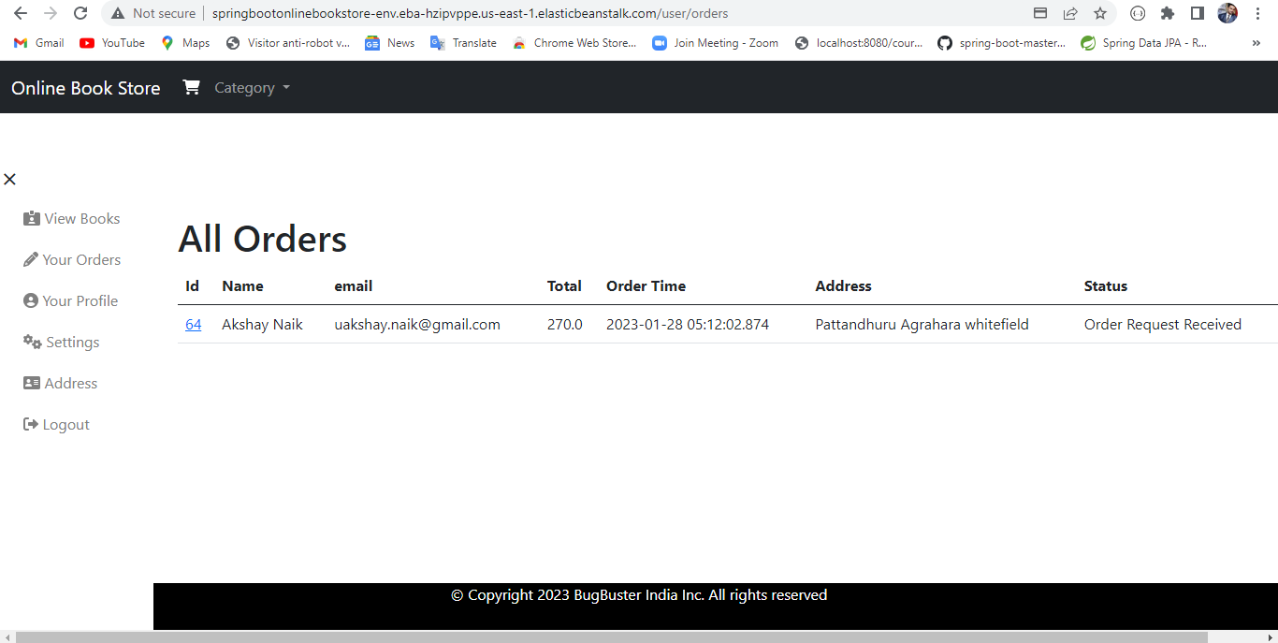

When the user clicks on the order id link it will show all the ordered books.

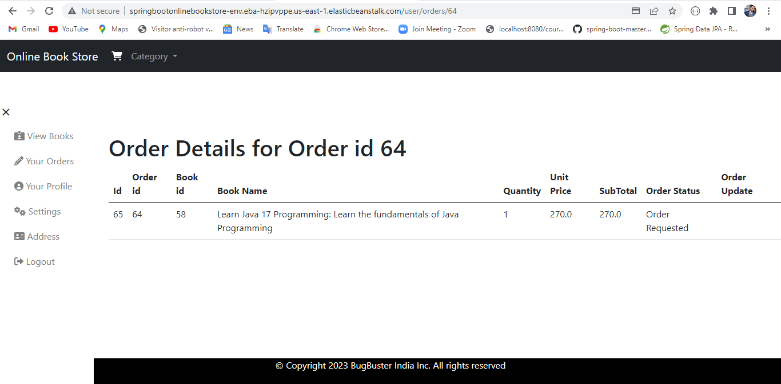

Admin Logging into the website

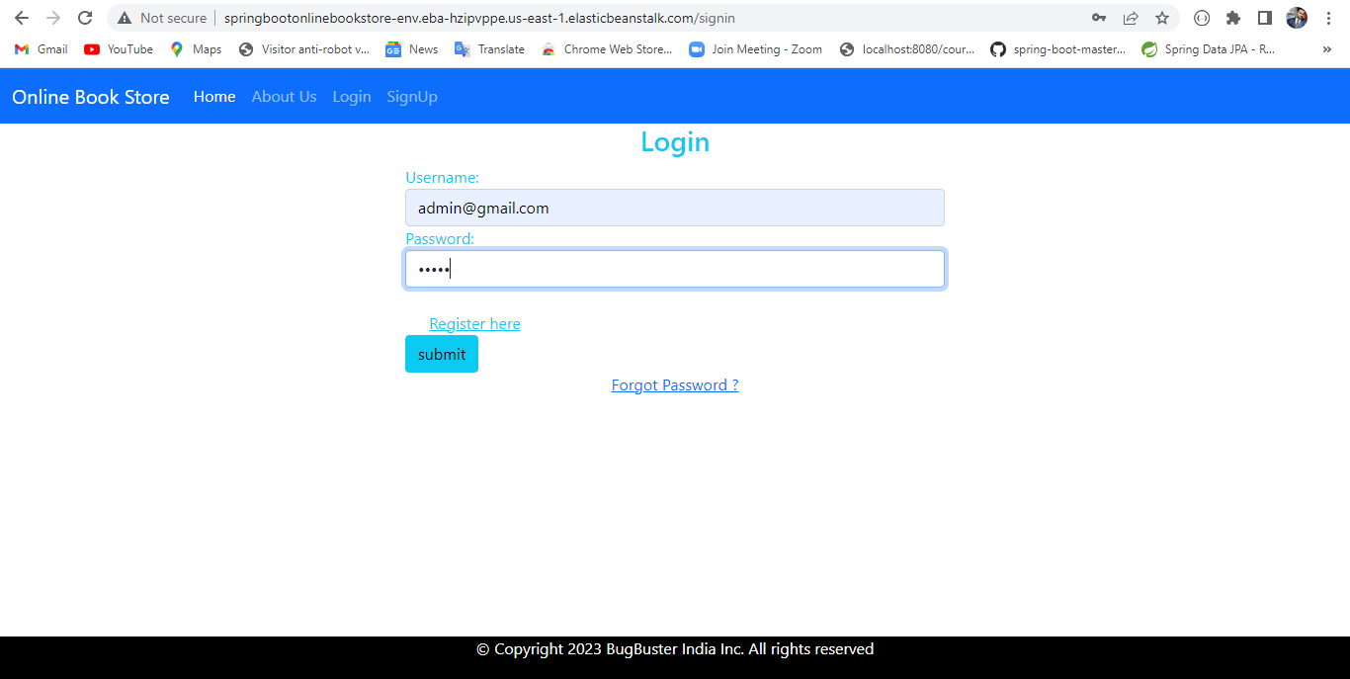

Admin Page after the successful admin login

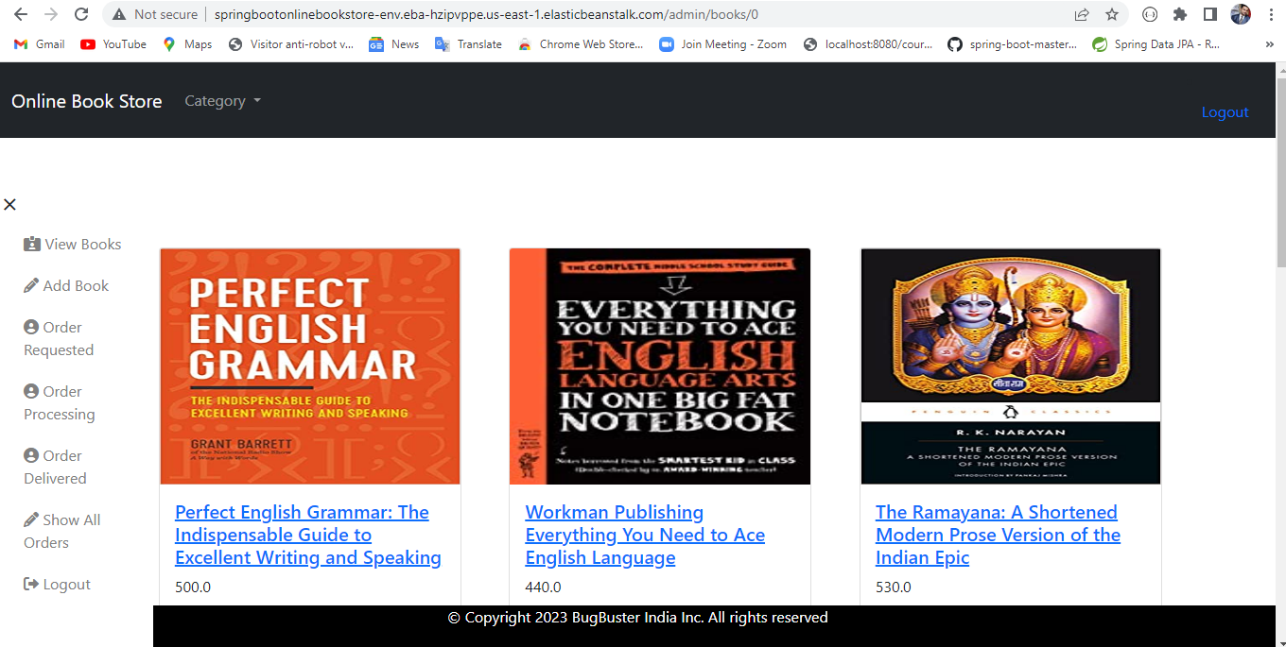

When the Admin clicks on order Requested button it will show this page

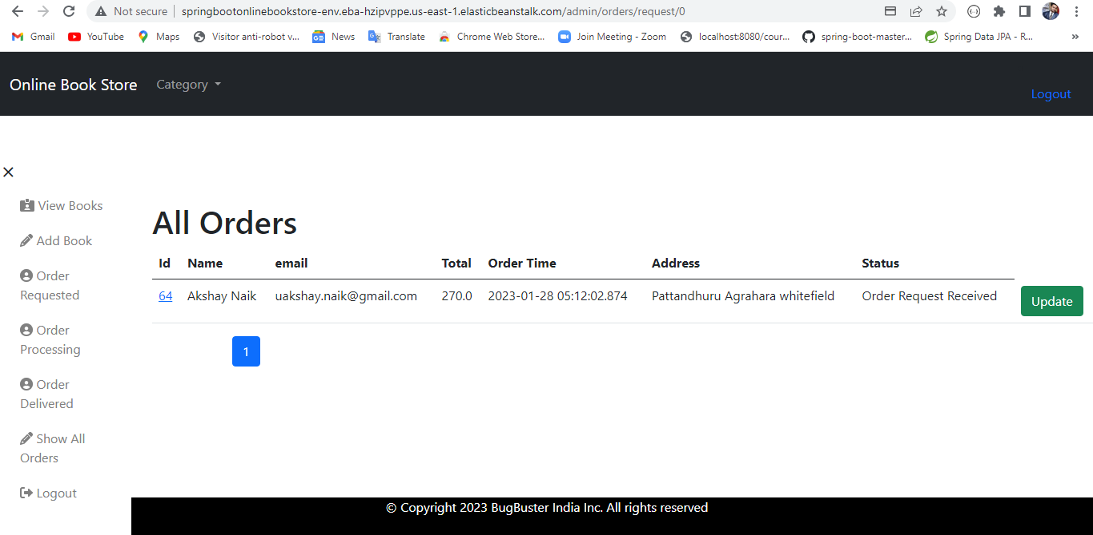

Admin is updating the order status from requested to processing by clicking on the update button.

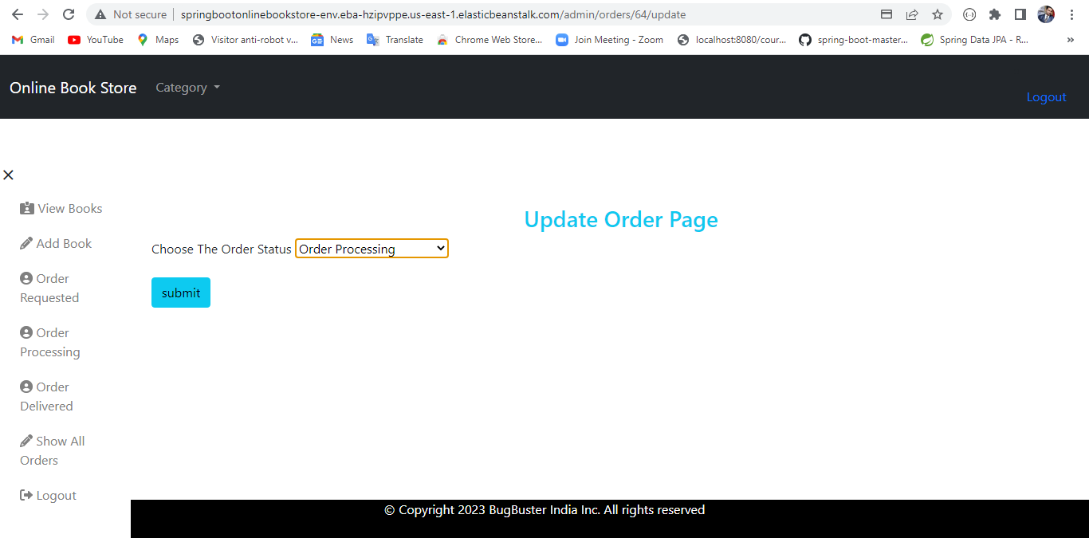

When the admin clicks on the order id link this page will appear which contains list of books ordered for particular order id.

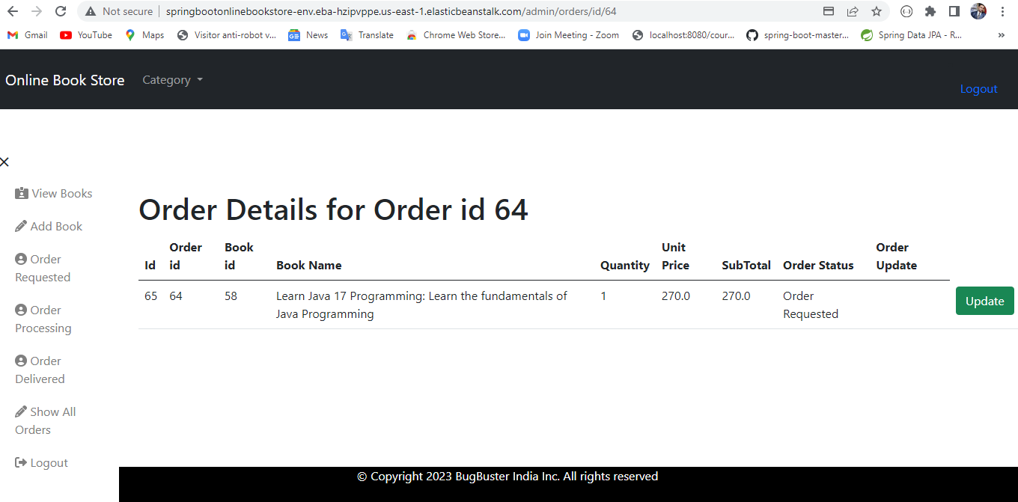

The admin is updating the order status and order update by clicking the update button.

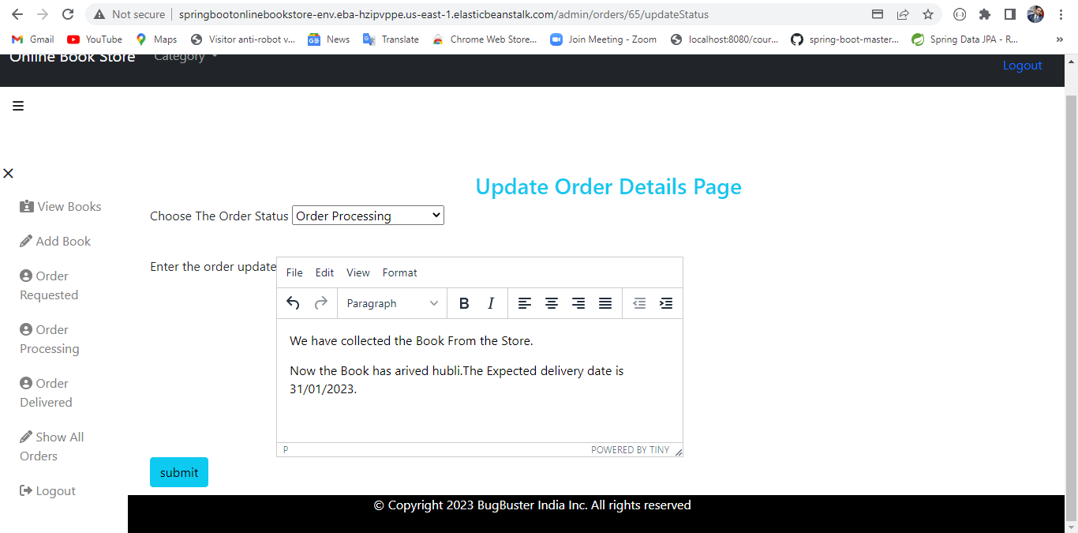

The user’s order status is updated from requested to processing after the admin updated the order status.

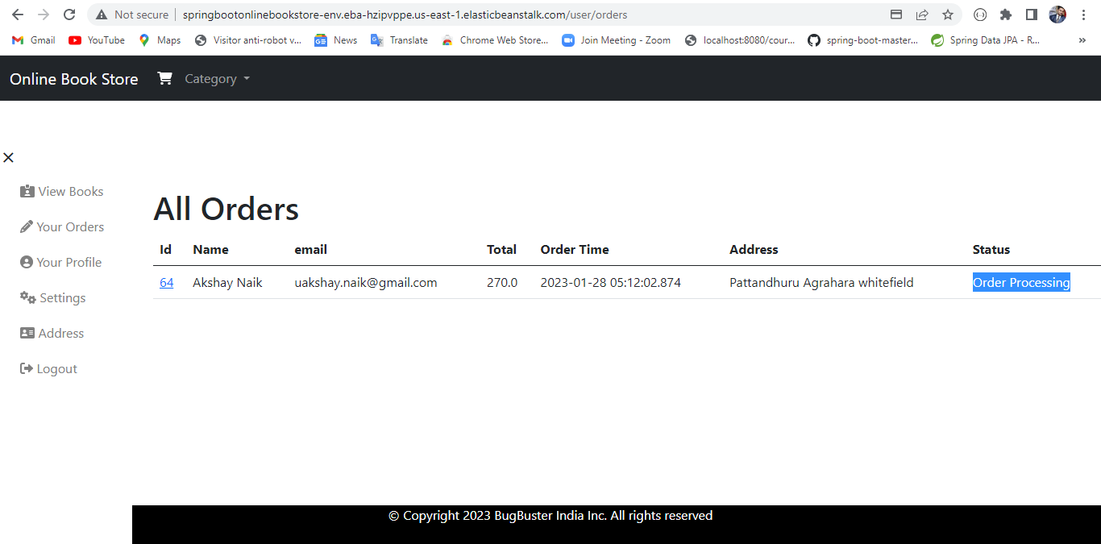

The User’s updated order status and order update for particular book.

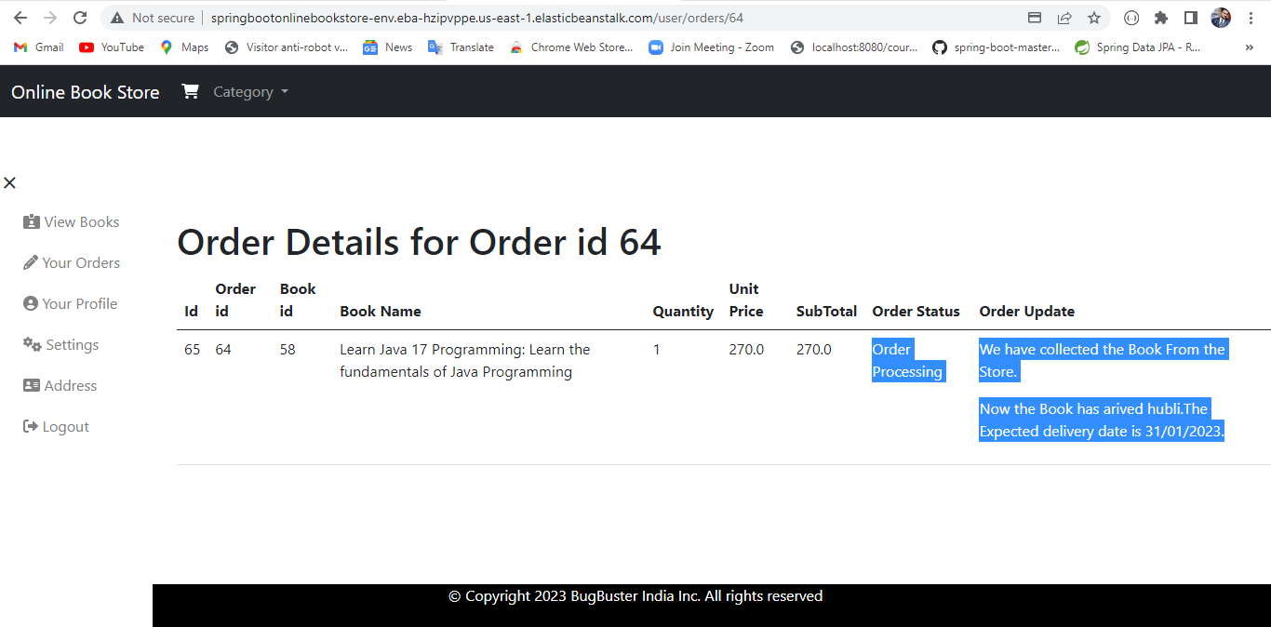

In the admin page All the requested order will be in the /admin/orders/request/0

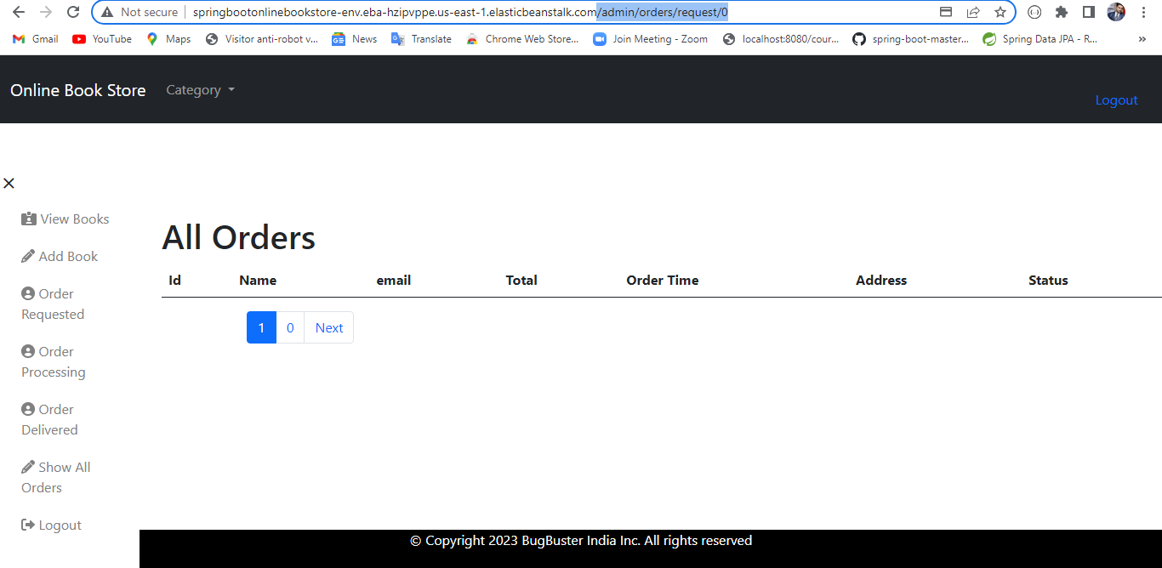

In the admin page All the processing order will be in the /admin/orders/process/0

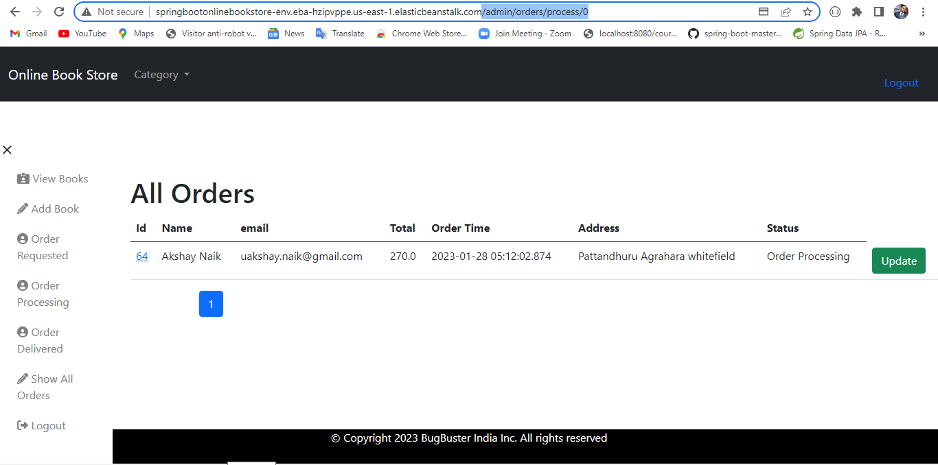

In the admin page All the delivered order will be in the /admin/orders/delivered/0

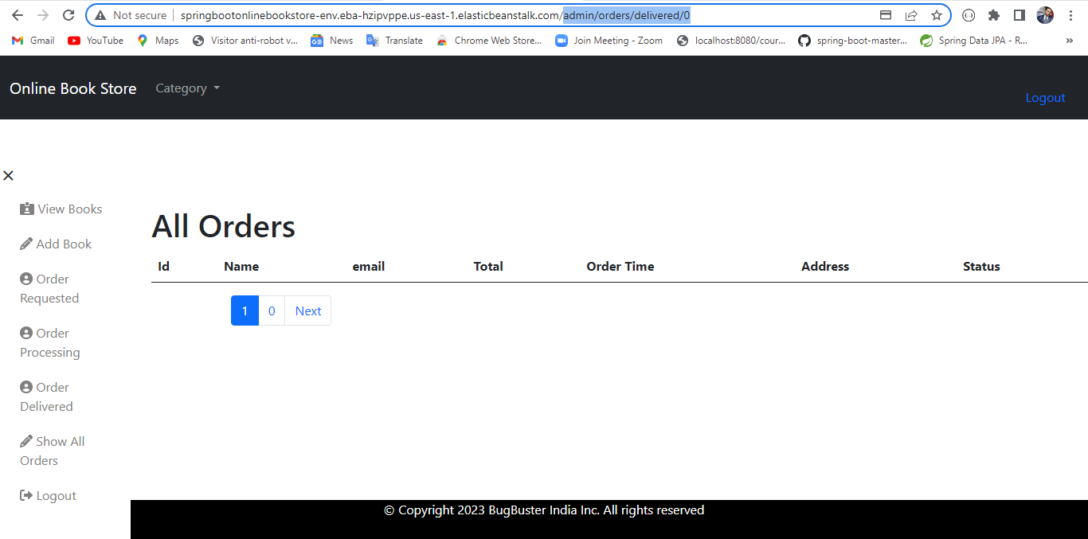

In the admin page All the order will be in the /admin/orders/0

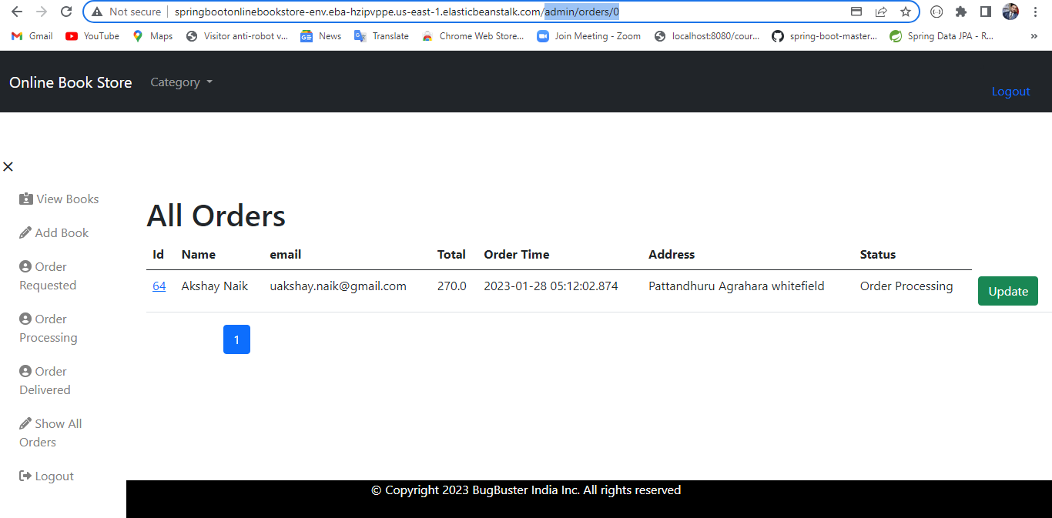

Admin can add the book by clicking on the add book link and fill the fields.

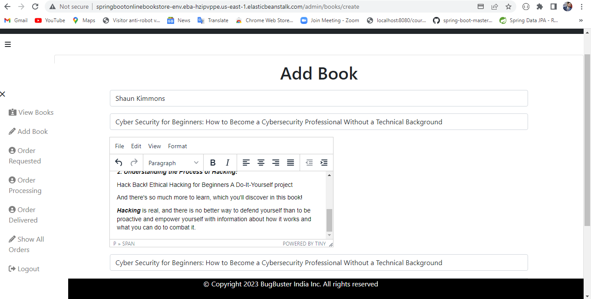

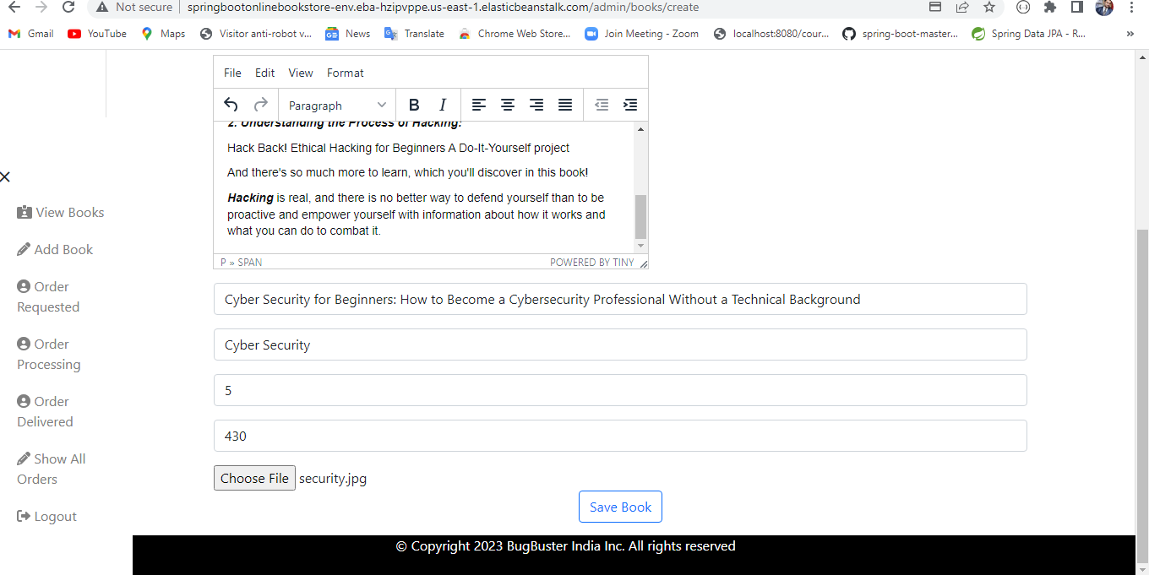

Once admin is added the books it will appear in the views all books page. The admin can update and remove the book.

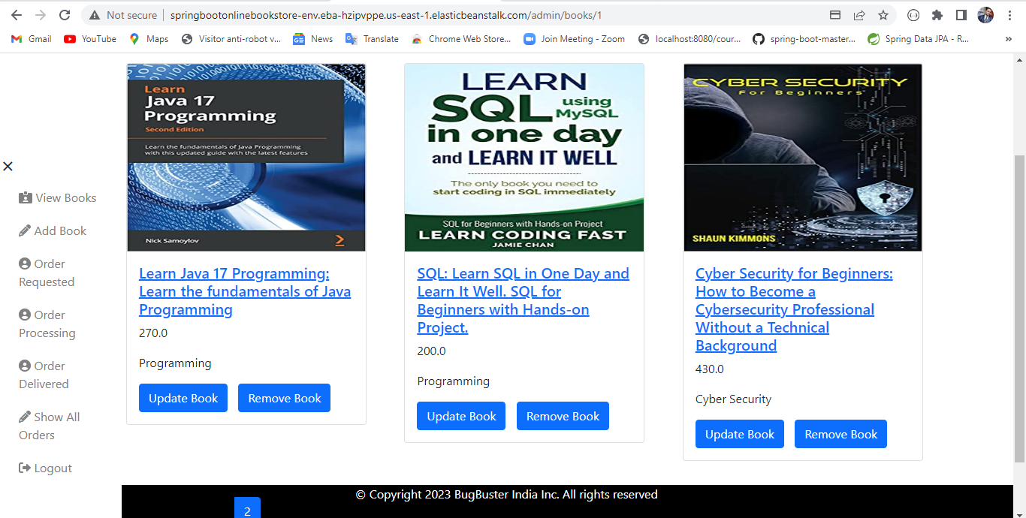

Update Book Page

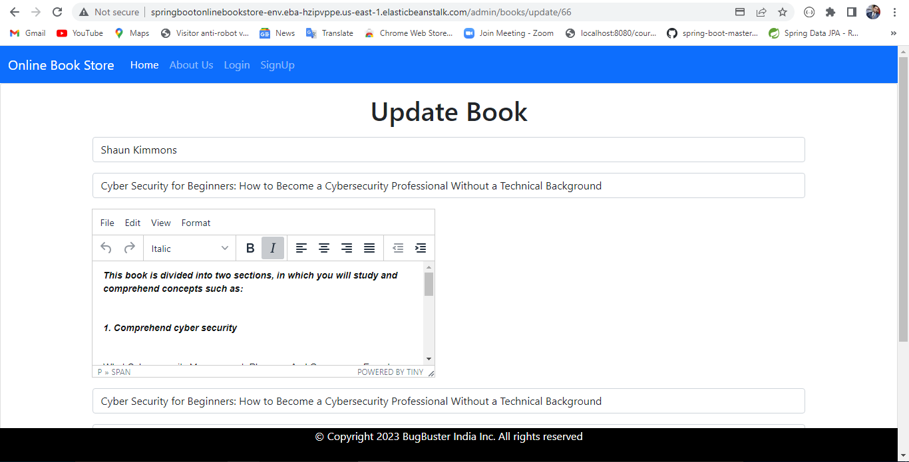

Displaying all the category of books.

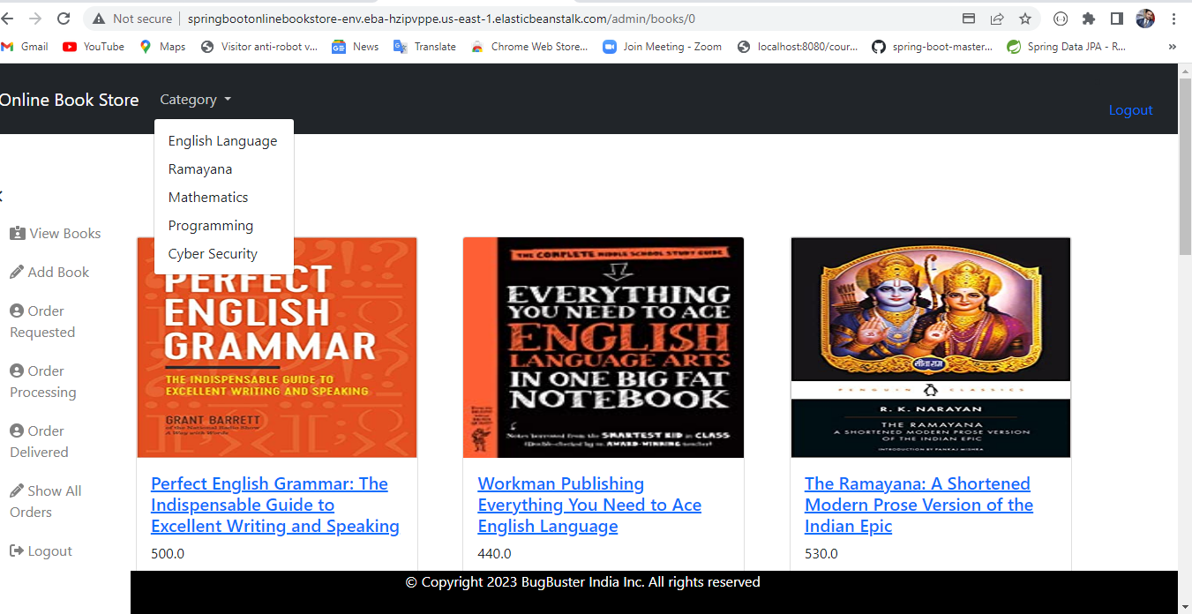

Here searched for the books having category English Language

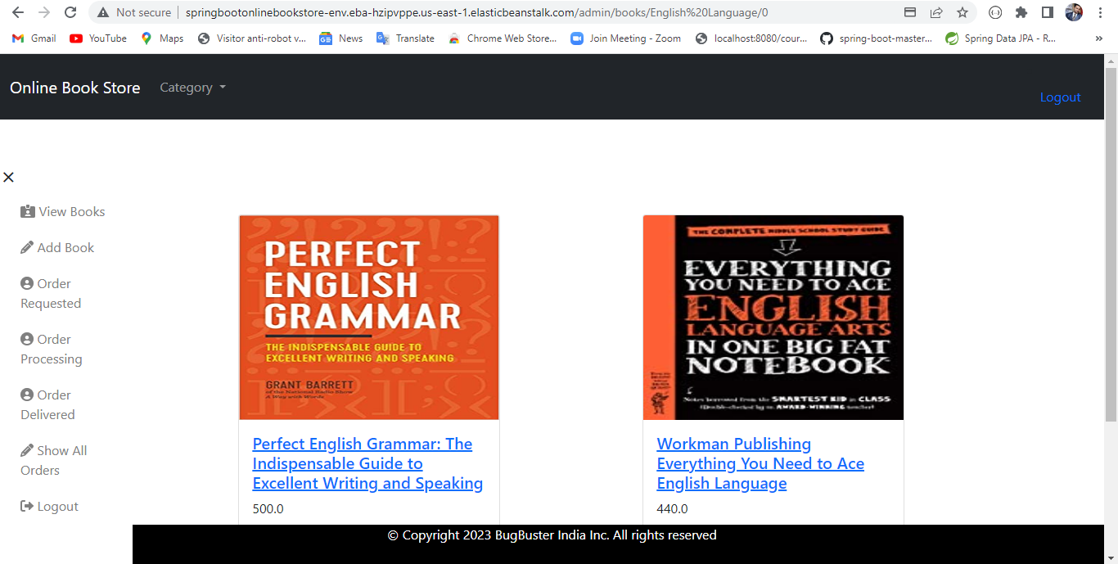

User’s profile page

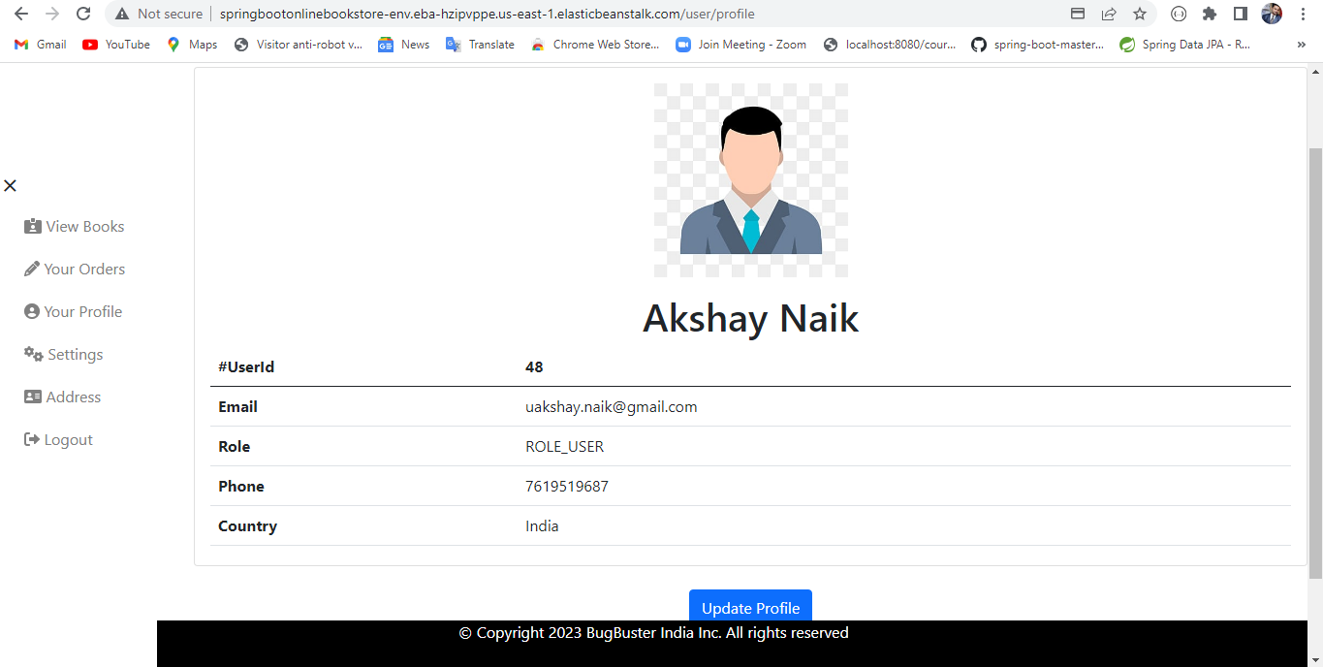

Update profile page

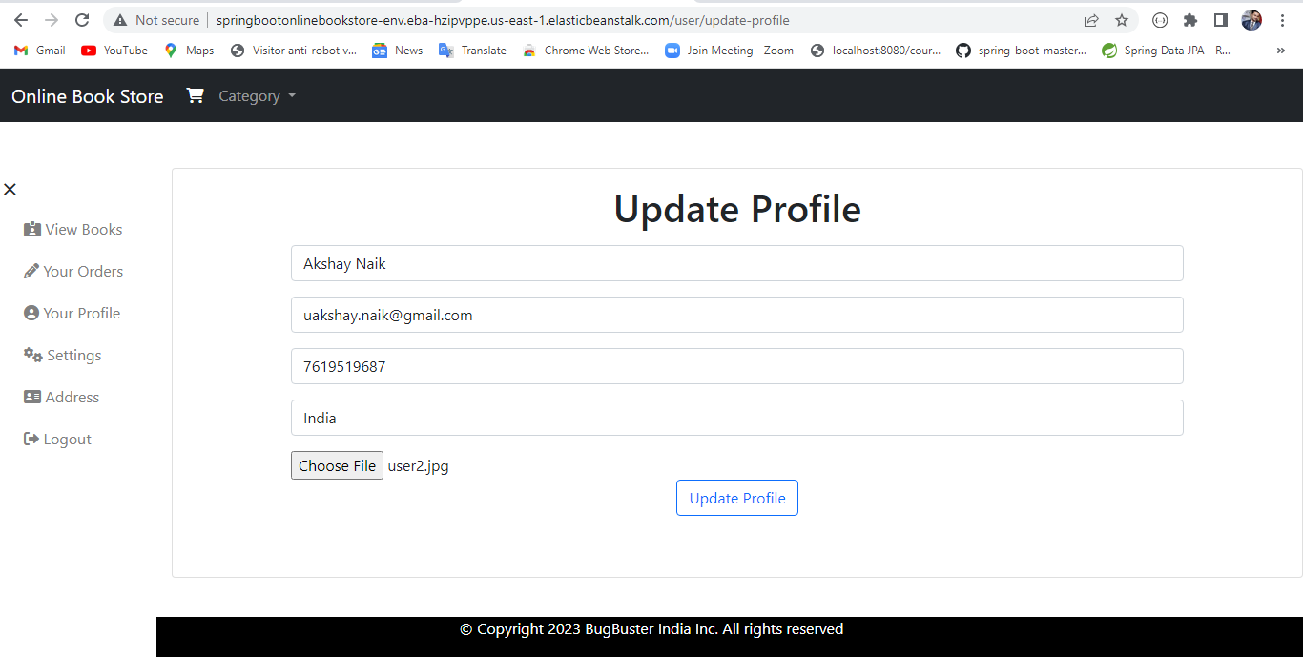

After updating the profile image.

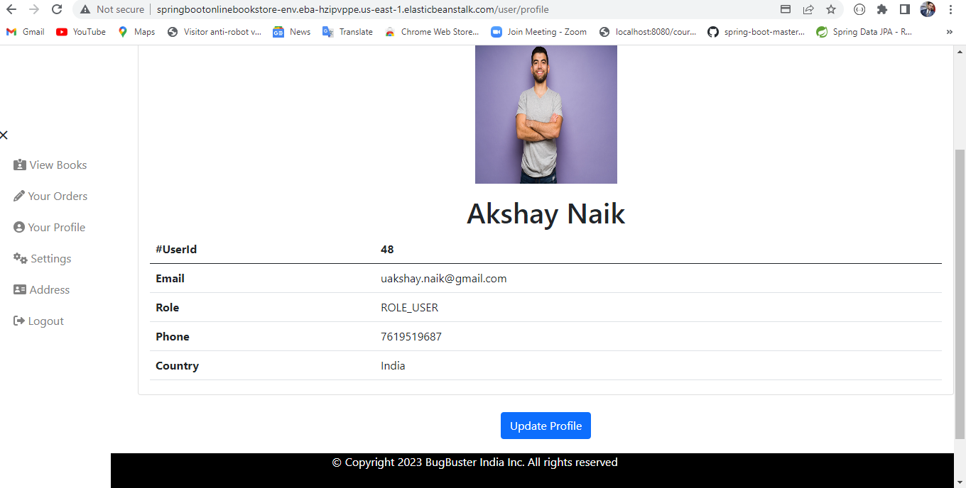

User can change the existing password by clicking on the settings button.

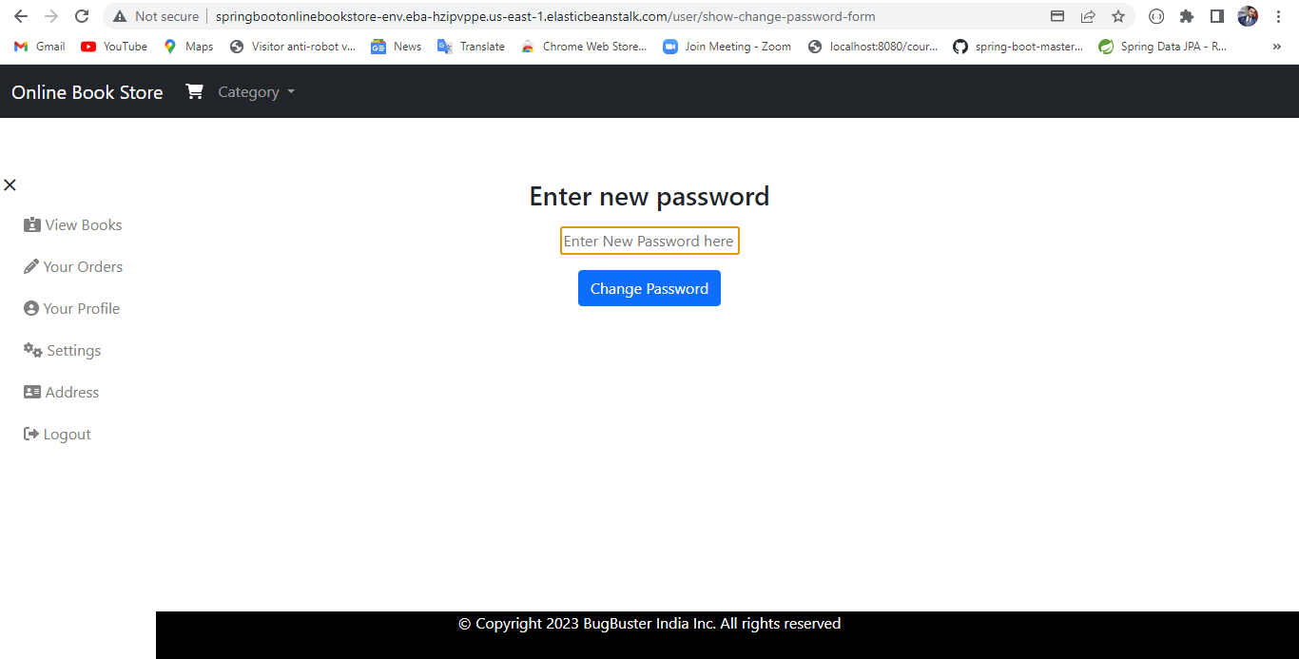

If the user forgot the password the user can reset the password through email.

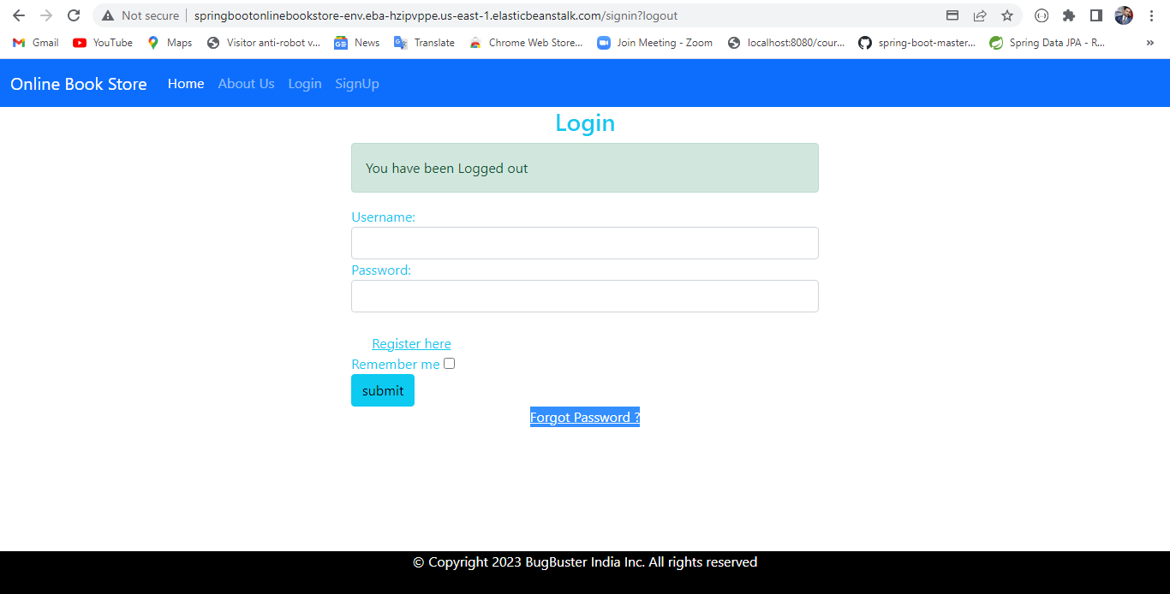

The user needs to enter the registered email address and click on send OTP.

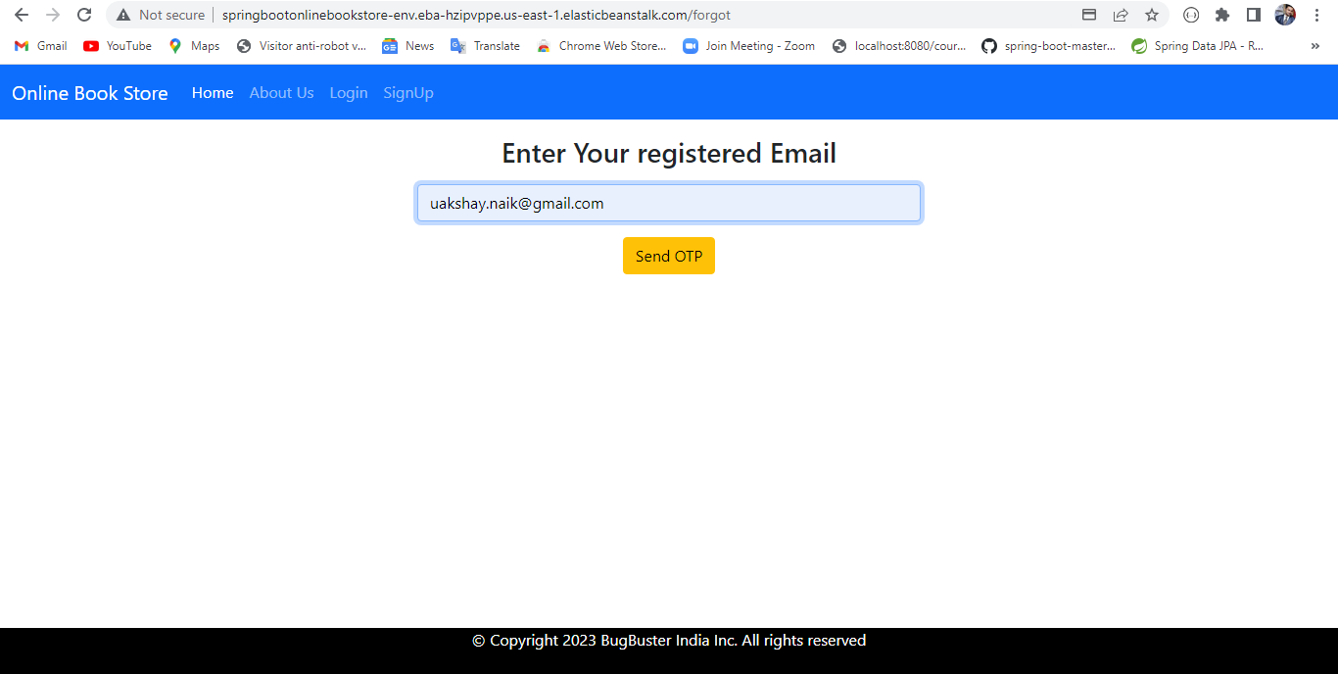

OTP has successfully send to user’s registered email id.

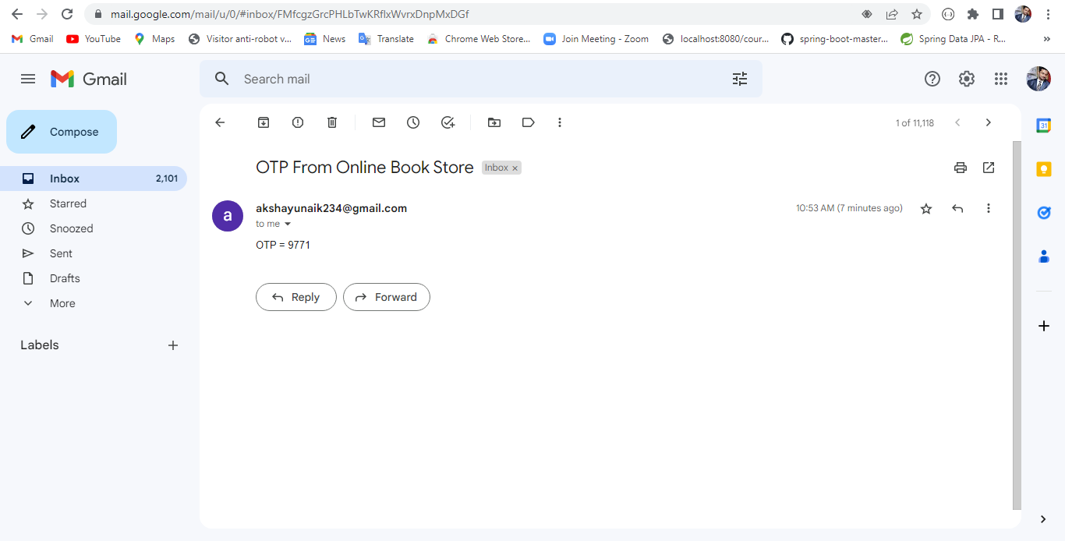

If the entered otp is correct then it will go to new password page.

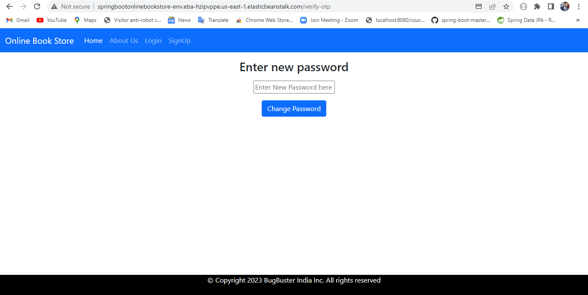

After entering the new password the password will be changed successfully.

